**Average of all the API’s**

**Accuracy and Confusion Matrix from Google API:**

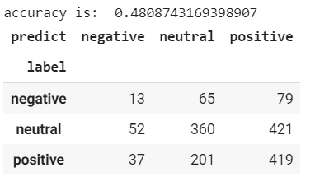

**Accuracy and Confusion Matrix from Watson API:**

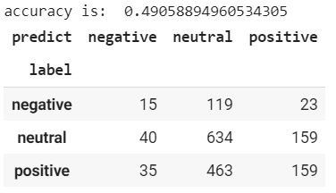

**Accuracy and Confusion Matrix from Azure API:**

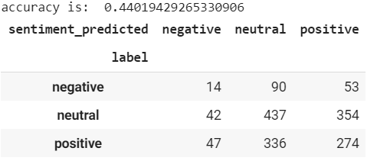

**Average Accuracy from all the API’s**

